# Question Answering

1. Question Answering – Given a question what is the answer given a context (BERT)
2. Transfer learning – Train for a specific task and apply it to a diff task (T5)
3. BERT – Looks at context from both directions of the word.

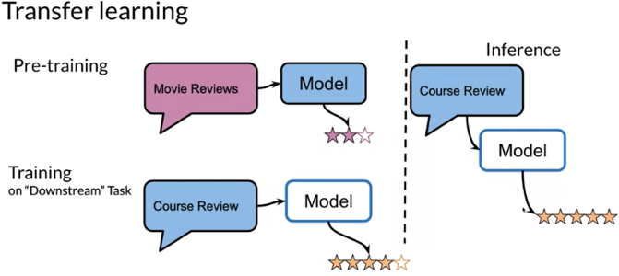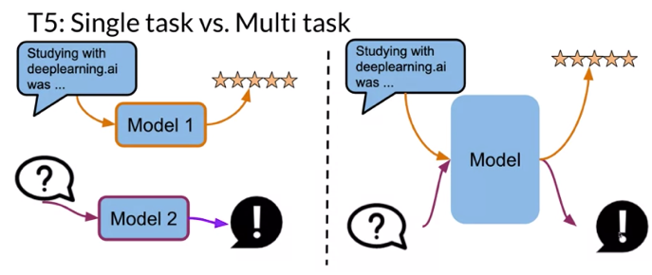

Transfer learning benefits

* Reduce training time

* Improve predictions

* Small dataset

**Transfer Learning in NLP**

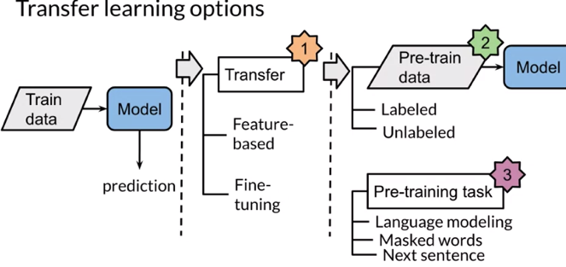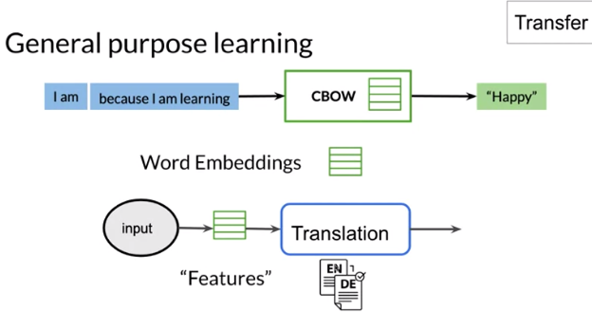

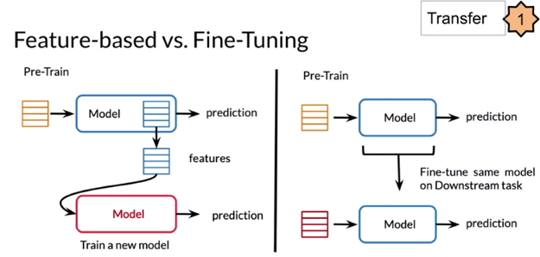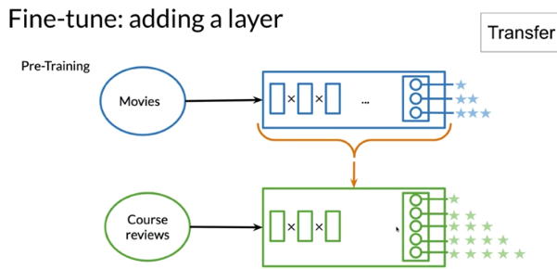

Larger the data better the performance

Self-supervised data, given unlabeled data you can create inputs or features. Then you create targets.

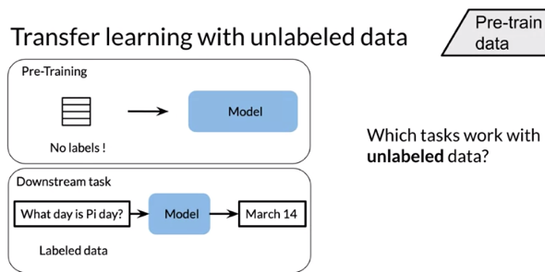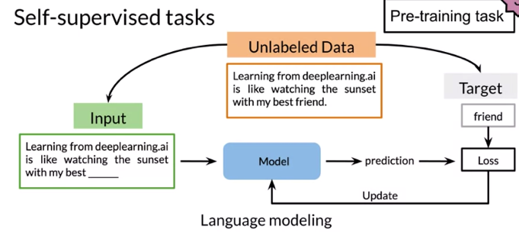

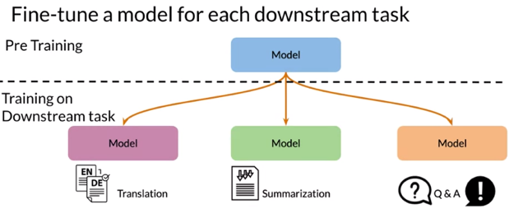

**ELMo, GPT, BERT, T5**

CBOW -> ELMo -> GPT -> BERT -> T5

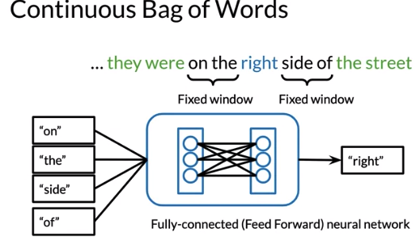

ELMo = Use all context words not just bigram on either side

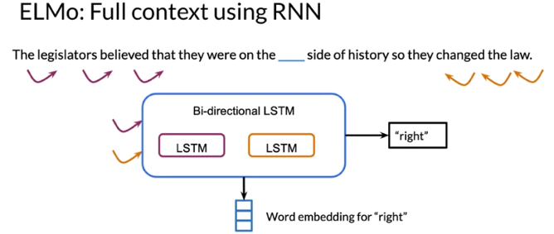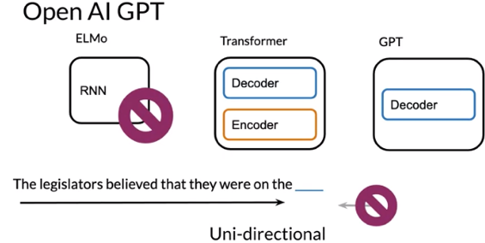

Open AI GPT

GPT is unidirectional. Uses just the decoder stack, does not have an encoder.

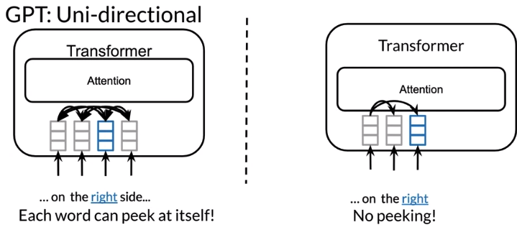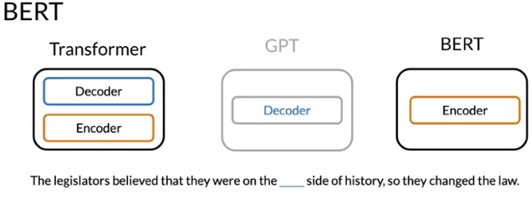

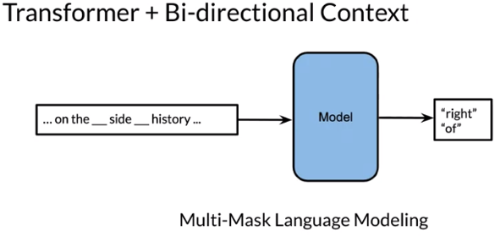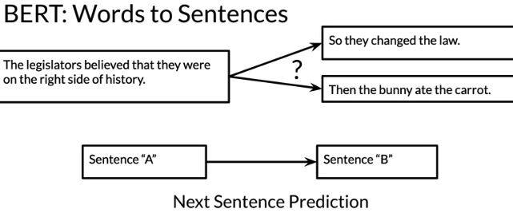

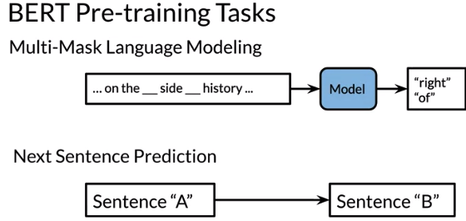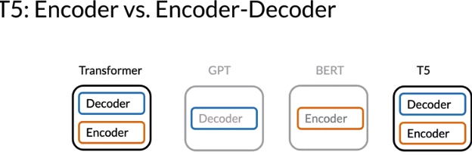

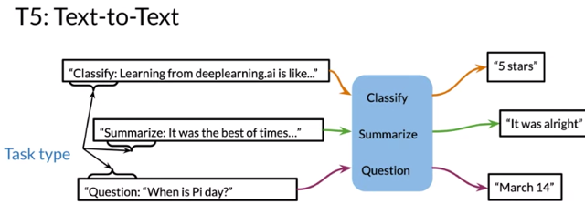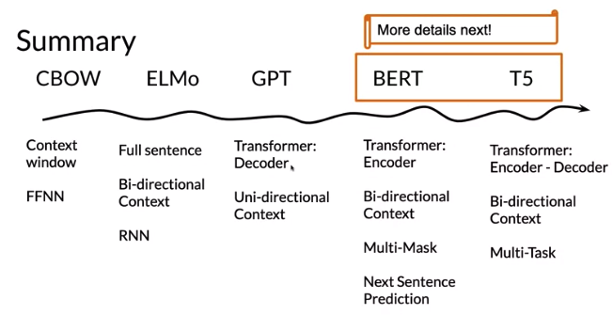

**Bidirectional Encoder Representations from Transformers (BERT)**

*. Input embedding

* Go through some transformer black.

* During pre-training model is trained on unlabeled data

* For fine-tuning, BERT is initialized with pre-trained params and all params are fine tuned using labeled data from downstream tasks.

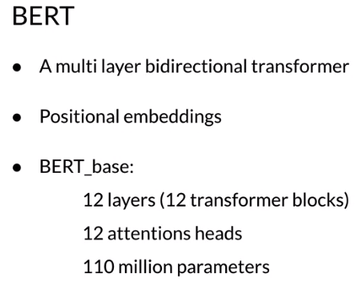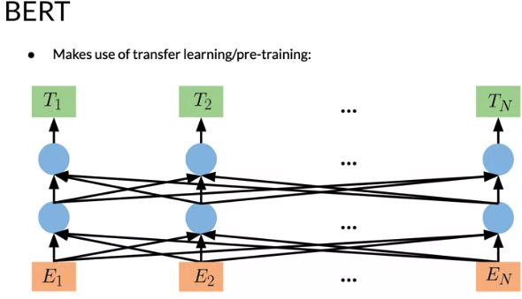

Before feeding the word sequences to the BERT model, we mask 15 percent of the words, and then, the training data generator chooses 15 percent of these positions at random for prediction. Then, if the ith token is chosen, we replace the ith token with one, the mask token 80 percent of the time, and then, two, a random token 10 percent of the time, and then, three, the unchanging ith token 10 percent of the time. In this case, then TI, which you've seen in the previous slide, will be used to predict the original token with cross-entropy loss. In this case, this is known as the masked language model. add the dense layer after the TI token and use it to classify after the encoder outputs. You just multiply the output's vectors by the embedding matrix, and then, to transform them into

vocabulary dimension and you add a softmax at the end.

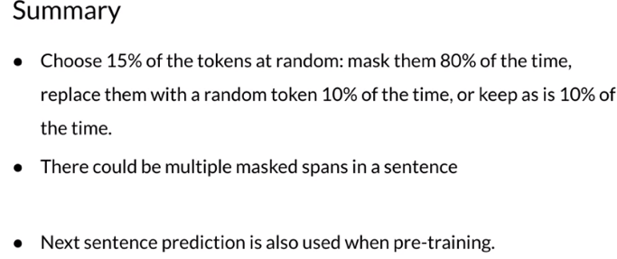

**BERT Objective**

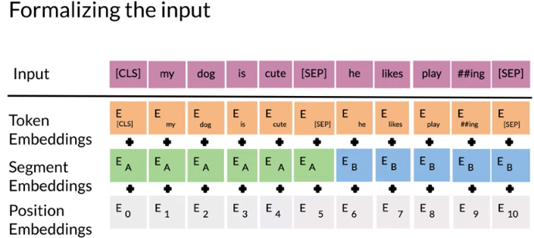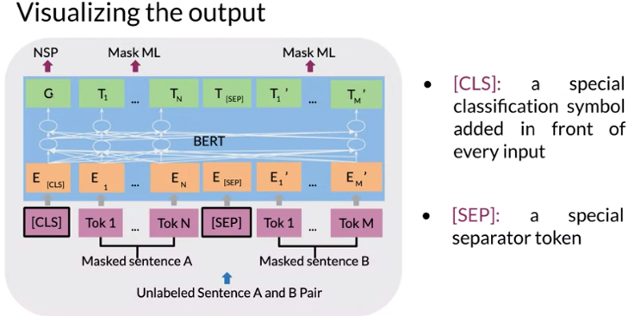

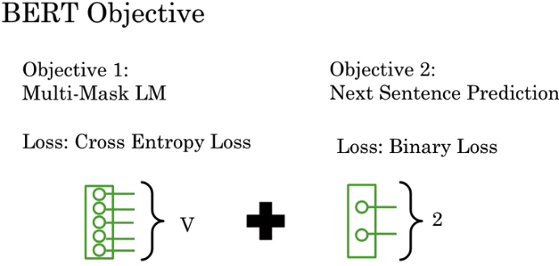

**Fine-tuning BERT**

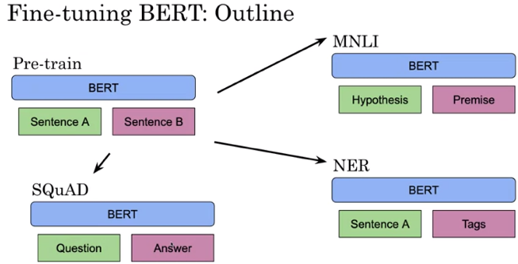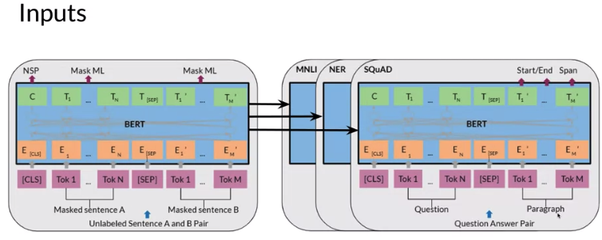

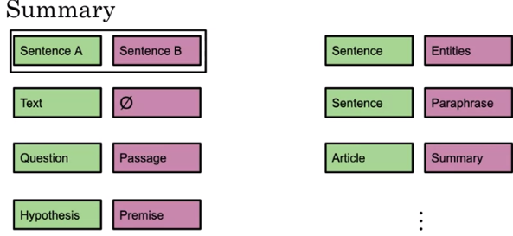

**Transformer: T5**

Transfer learning + Mask language modeling

Uses transformers when training

Applications

* Classification

* Machine Translation

* Question and Answering

* Summarization

* Sentiment

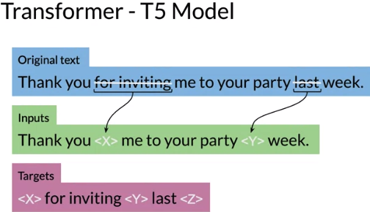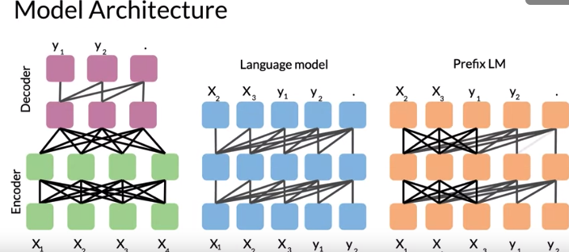

Model Architecture

* Encoder/Decoder

* 12 transformer blocks each

* 220Million params

**Multi-Task Training Strategy**

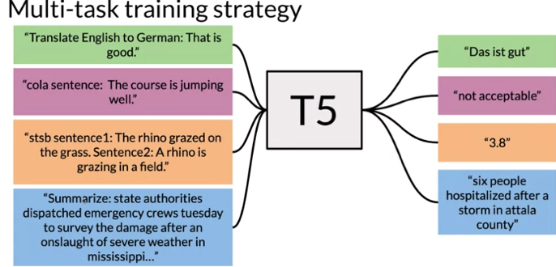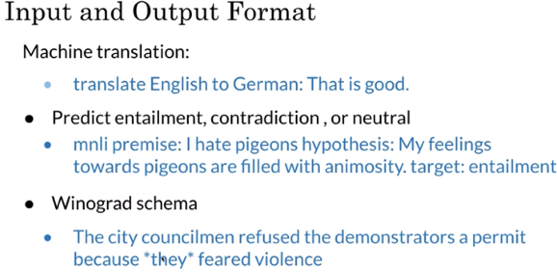

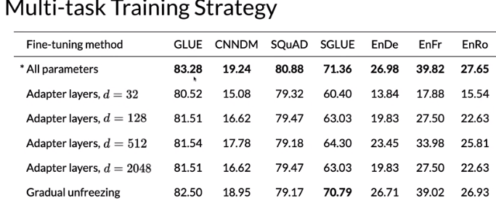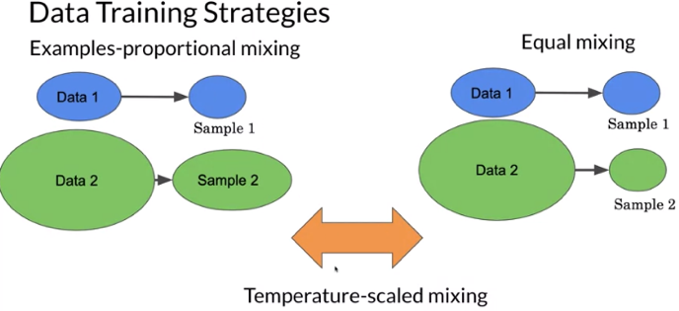

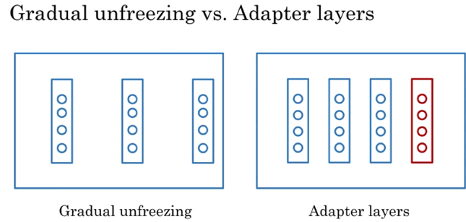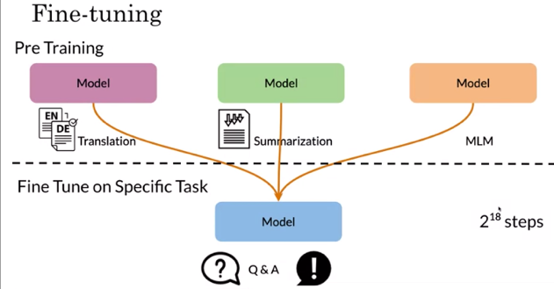

**GLUE Benchmark – General Language Understanding Evaluation**

GLUE is a collection of resources training, evaluating, and analyzing, natural language understanding systems.

* Drive research

* Model agnostic

* Makes use of transfer learning

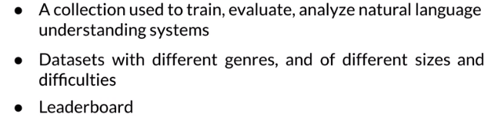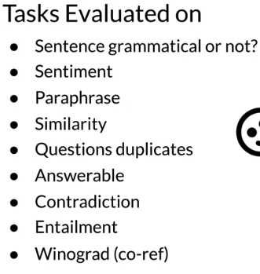

**Question Answering**

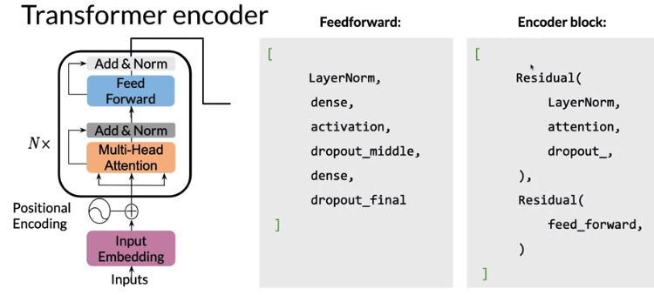

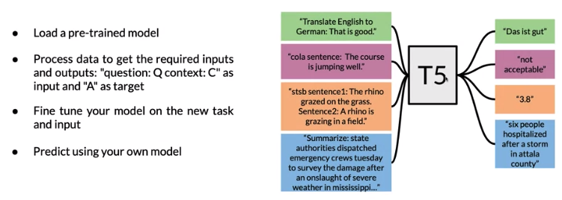

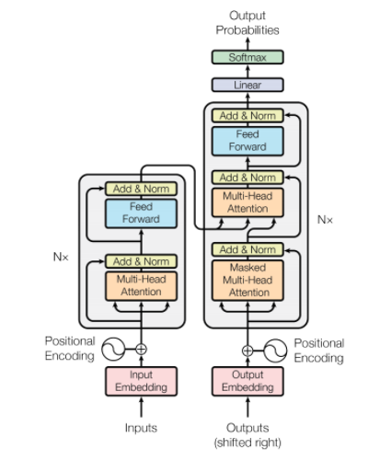

from unicodedata import normalize

def get_hex_encoding(s):

return ' '.join(hex(ord(c)) for c in s)

# Replace tabs and newlines and white space with ‘\u2581’

BPE (Byte pair encoding) algo

import ast

def convert_json_examples_to_text(filepath):

example_jsons = list(map(ast.literal_eval, open(filepath))) # Read in the json from the example file

texts = [example_json['text'].decode('utf-8') for example_json in example_jsons] # Decode the byte sequences

text = '\n\n'.join(texts) # Separate different articles by two newlines

text = normalize('NFKC', text) # Normalize the text

with open('example.txt', 'w') as fw:

fw.write(text)

return text